Virtual machine

1. Go to the official VirtualBox website: https://www.virtualbox.org/
2. Click on the "Downloads" link in the top navigation menu.
3. Download the installer for Windows and double-click on the downloaded file to start the installation.
4. Post-installation Configuration
5. Launch VirtualBox from your applications menu or desktop shortcut.
6. Add you account user account to the "VirtualBox Users" group (Windows)
7. 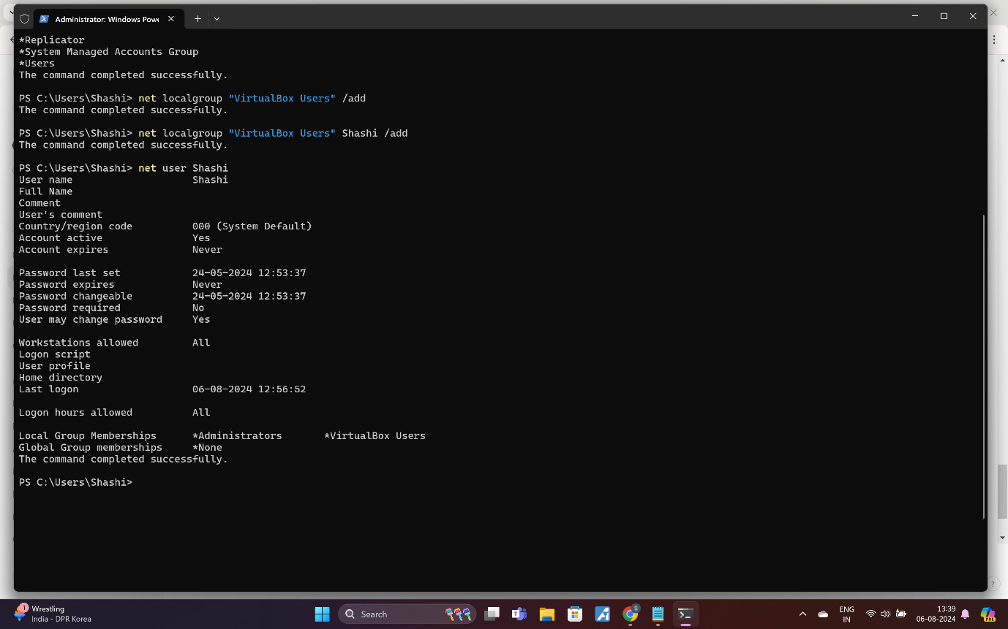
8. Click on the "New" button in the VirtualBox Manager.
9. Set Up the VM:
10. Name: Enter a name for your virtual machine.
11. Type: Select "Linux".
12. Version**:** Choose "Ubuntu (64-bit)" or the appropriate version based on the VDI you downloaded. 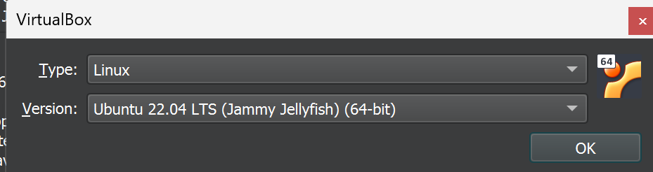
13. Allocate the recommended amount of RAM. For Ubuntu, at least 2 GB (2048 MB) is a good start, though more is better if you have enough system RAM.
14. When prompted to create a hard disk, select "Use an existing virtual hard disk file".

Click the folder icon next to the drop-down menu and navigate to where you downloaded the VDI file.

Select the VDI file and click "Open".

**Note**: Network configuration is very important so host machine and Guest machine work correctly as per the requirement

1. Select the newly created VM in the VirtualBox Manager and click "Start".
2. After installation here “osboxes” user . so we need to login and start working as per the instruction
3. Now Installing nginx
4. First, ensure your system packages are up to date.
5. sudo apt update
6. sudo apt upgrade -y
7. sudo apt install nginx -y
8. sudo systemctl start nginx
9. sudo systemctl enable nginx
10. sudo mkdir -p /var/www/mywebsite
11. sudo chown -R www-data:www-data/var/www/mywebsite
12. sudo chmod -R 755 /var/www/mywebsite
13. vim /var/www/mywebsite/index.html
14. sudo vim /etc/nginx/sites-available/mywebsite
15. server {
16. listen 80;
17. server_name your_domain_or_IP;
18. root /var/www/mywebsite;
19. index index.html;
20. location / {
21. try_files $uri $uri/ =404;
22. }
23. }
24. sudo ln -s /etc/nginx/sites-available/mywebsite /etc/nginx/sites-enabled/
25. sudo nginx -t
26. sudo systemctl reload nginx
27. 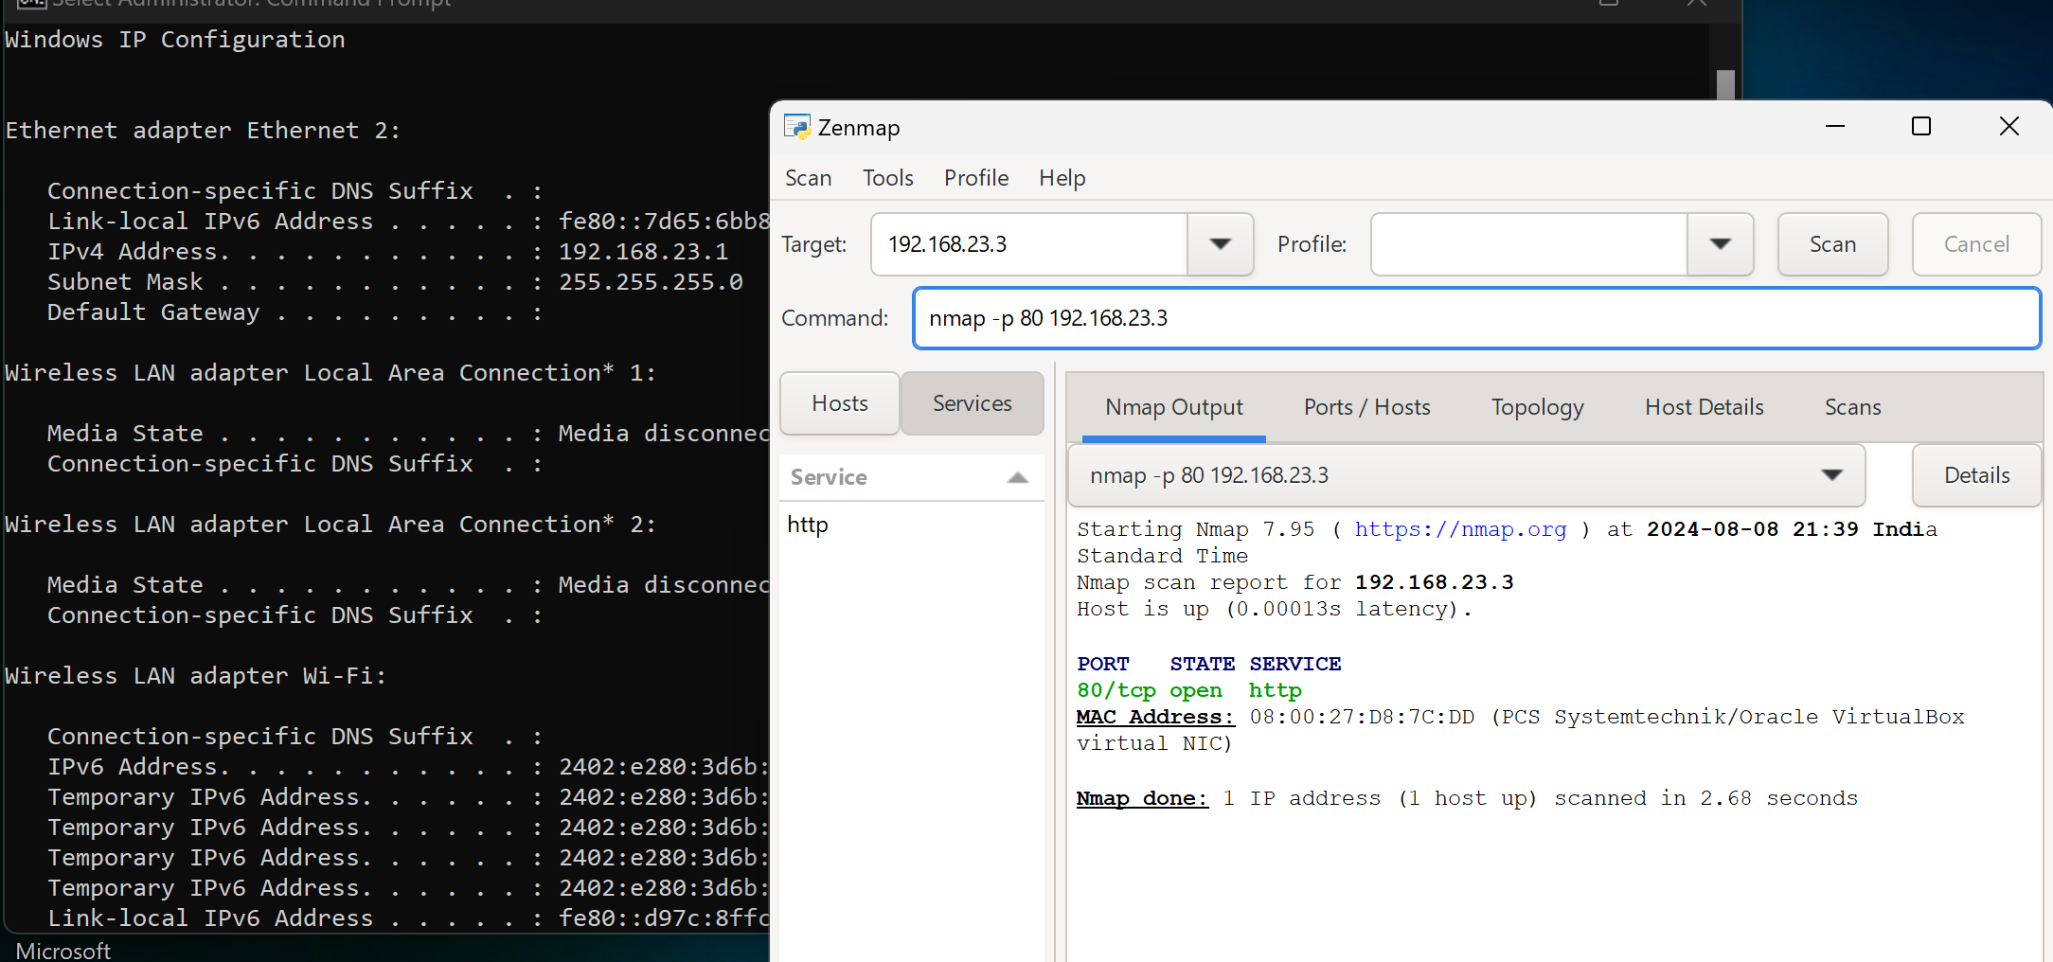
28. 